Website Report

Petar Stanev

Web Development and HCI

University of Salford

# 1. Site content and design

* Url of the website - <http://zeus.cs.salford.ac.uk/wpd/site80/>
* The website is about dental center in small city of Bulgaria. After it is finished it will be upload to host and will be official website of the dental center.
* Hybrid. More information in 3.1 (Layout).

# 2. Use of HTML5

Information about the tags I used in my webpage.

**<div id="container">** - I use container to wrap my all my content on the page.

**<header>** - This is where header of the page is.

**<h1>, <h2> and <h3>** - They are used to show text as header tag. The bigger the number the bigger the size of the font is.

**<nav>** - This is where my navigation links are in the website.

**<ul>** - This defines unordered list of elements.

**<li>** - Is new element in the list.

**<a>** - This is used for making a link.

**<main>** - This is where the main content of the webpage is. The main content is different on every page while header, nav and footer are the same.

**<section>** - Represents a generic document.

**</p>** - Phrasing content.

**<strong>** - Make content important.

**<em>** - Emphasis content.

**<figure>** - It is intended to be used for illustrations, photos, and code examples.

**<figcaption>** - It is used to give information about the figure.

**<img>** - It is used for images.

**<table>** - It is used for tables.

**<tr>** - It is used for declaring table row.

**<td>** - It is used for making cell in the table.

**<footer>** - This is where footer of the page is.

**<address>** - Provides contact information.

# 3. CSS Explanation

## 3.1 Layout and positioning

My website is actually a hybrid. I use max-width of 1020px for my main div (container). This way my content is readable and not spread across the whole screen on devices with high resolution. Here is an example in full HD(1920X1080).

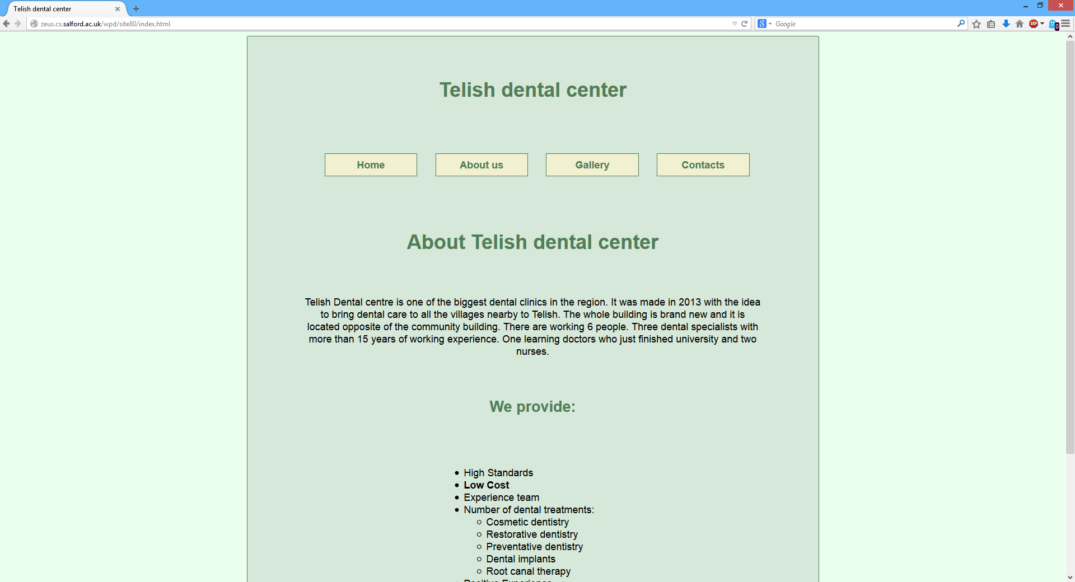

Figure 3.1.1 Firefox 34 on resolution 1920X1080

The content look same on some monitors with standard resolution for example 1024x768. Only difference there is not so much space from the left and right side of the contenet.

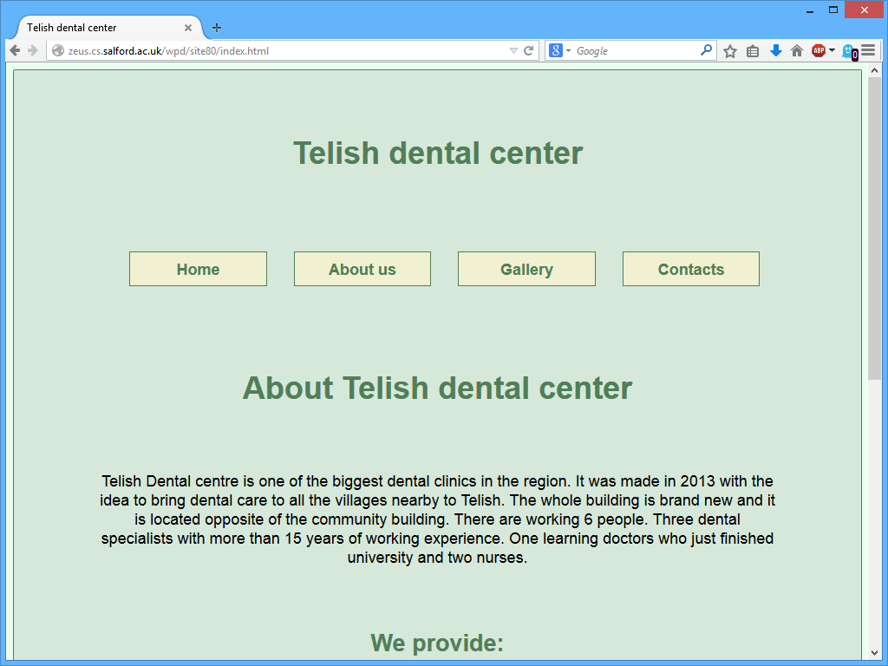

Figure 3.1.2 Firefox 34 on resolution 1024X768

In case screen size is less than 1020px (tablets or small monitors) my content fill up almost the whole screen, but the design stay the same.

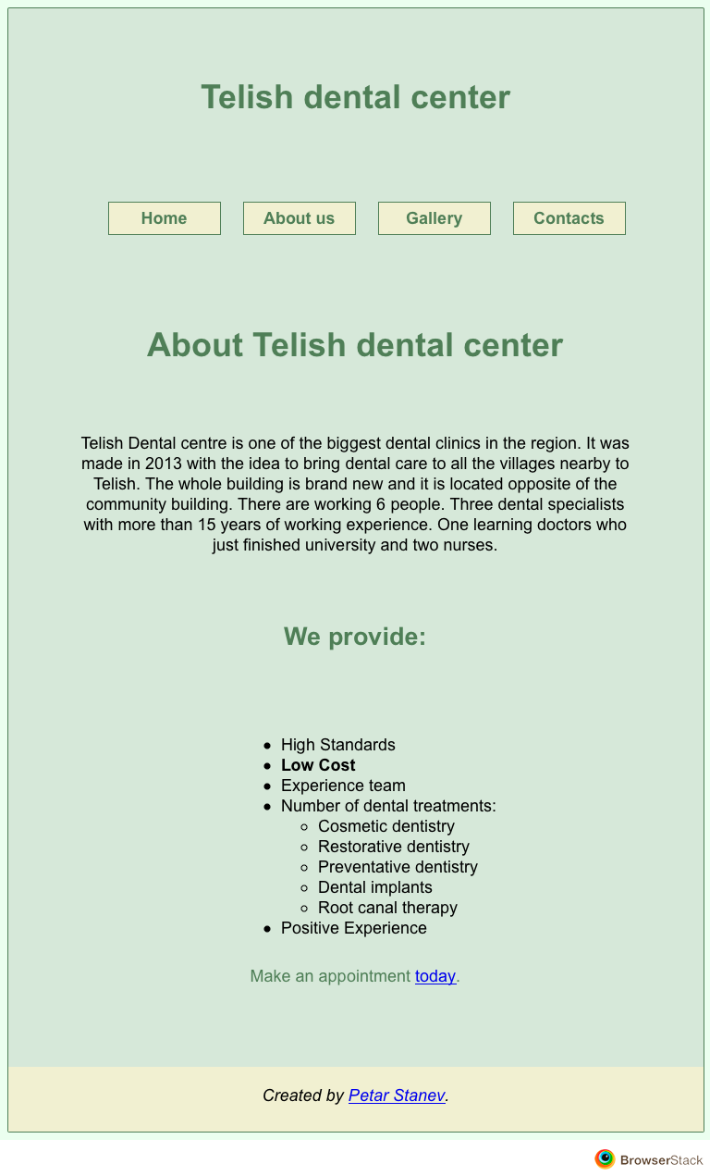

Figure 3.1.3 iPad portrait

There is also mobile view witch make the content full the screen and there is no background in that case. Also the buttons for the links go to vertical mode so that way it will be easier for the user to navigate through pages.

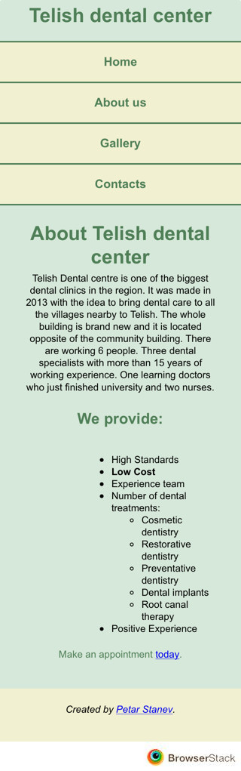

Figure 3.1.4 iPhone 5S

## 3.2 Colour scheme

For my colour scheme I used software called Adobe Color CC (<https://color.adobe.com>) which is free. I used three colours for my web page and black for content font colour. 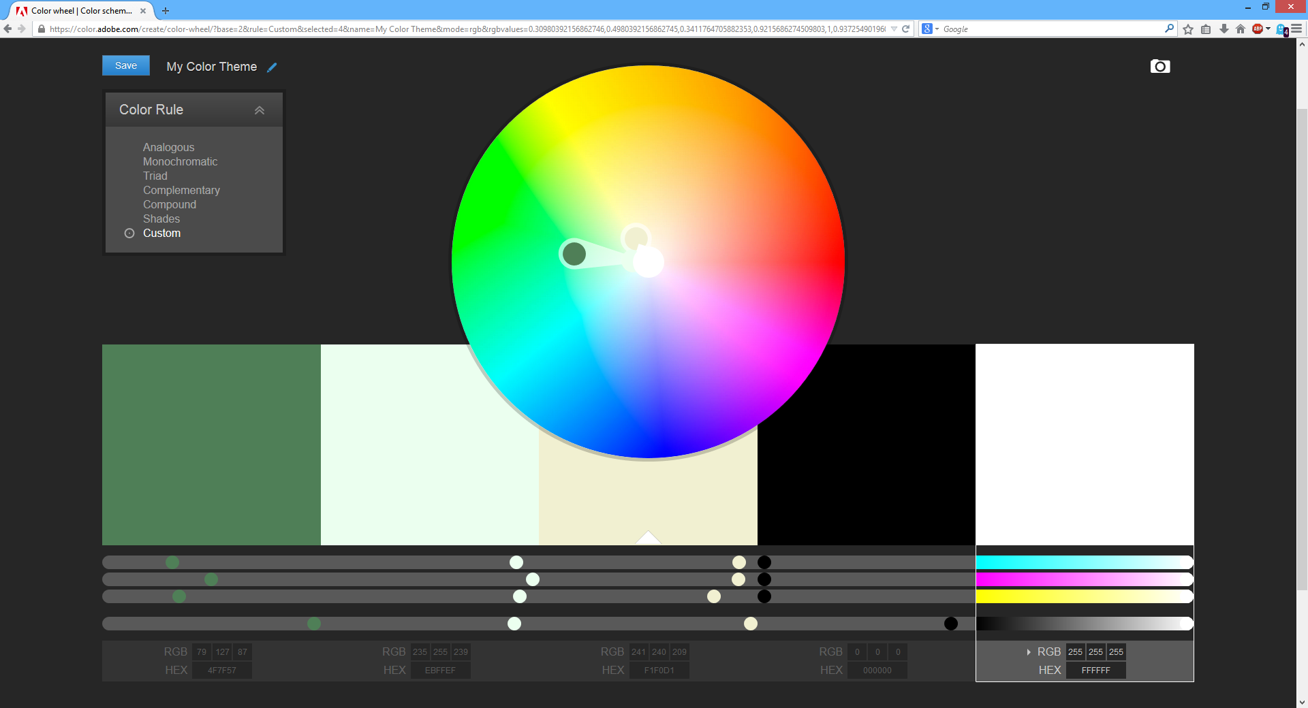

Figure 3.2.1 Adobe Color CC colour scheme.

## 3.3 interesting CSS elements

Probably the most interesting is the @media screen element. It prevents the CSS inside it from being run unless the browser passes the tests it contains. I have used it 2 times with max-width: 760px and max-width: 480px. When the screen is smaller than 760px the website goes to mobile view. The biggest change is that navigation goes from vertical to horizontal. The main idea is that user can use the website from mobile quickly without scrolling horizontal.

# 4. CSS Techniques

How To Use CSS3 Media Queries To Create a Mobile Version of Your Website - <http://www.smashingmagazine.com/2010/07/19/how-to-use-css3-media-queries-to-create-a-mobile-version-of-your-website/>

Using CSS for Image Borders - <http://css-tricks.com/using-css-for-image-borders/>

Phone Number Links - <http://code.tutsplus.com/tutorials/mobile-web-quick-tip-phone-number-links--mobile-7667>

# 5. Testing

## 5.1 Desktop

* Windows 8.1 Firefox 30.0

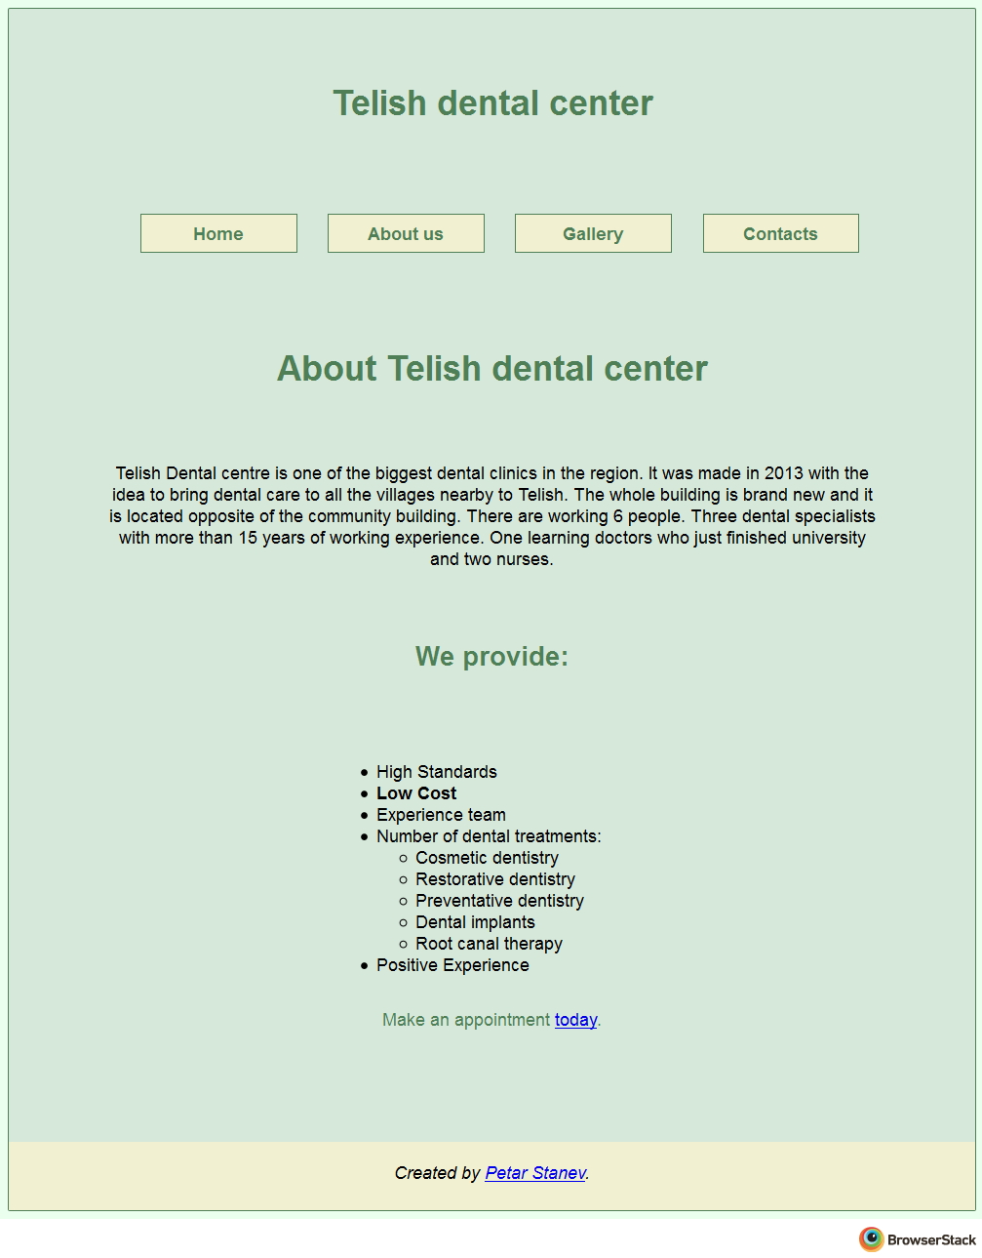

* Mac OS X Yosemite Chrome 36.0

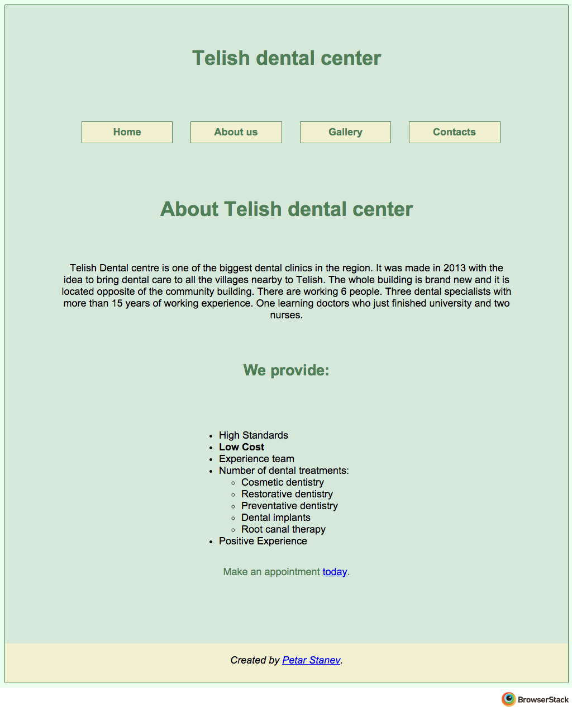

* Mac OS X Yosemite Opera 12.15

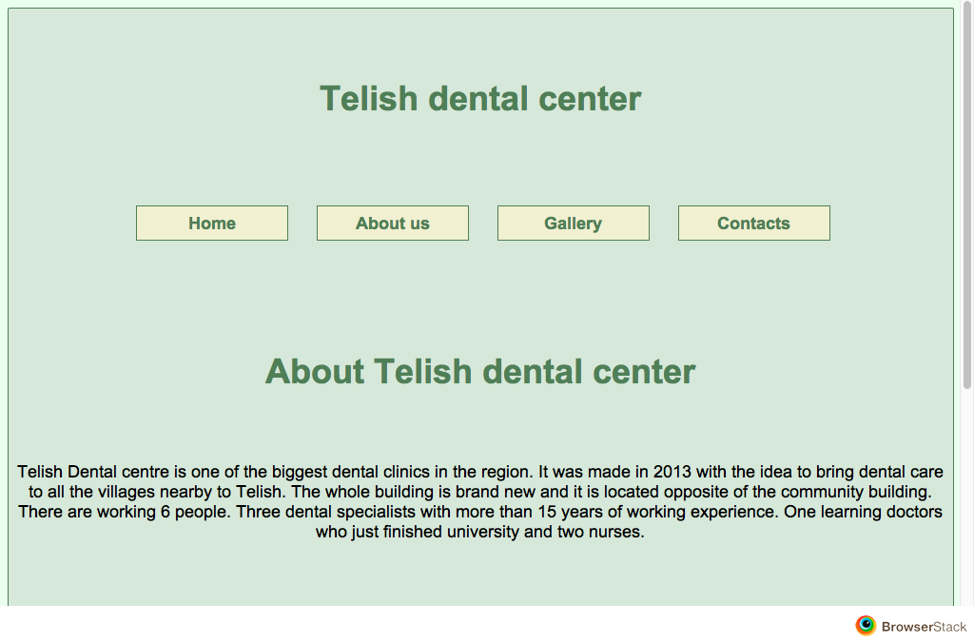

* Mac OS X Yosemite Safari 8.0

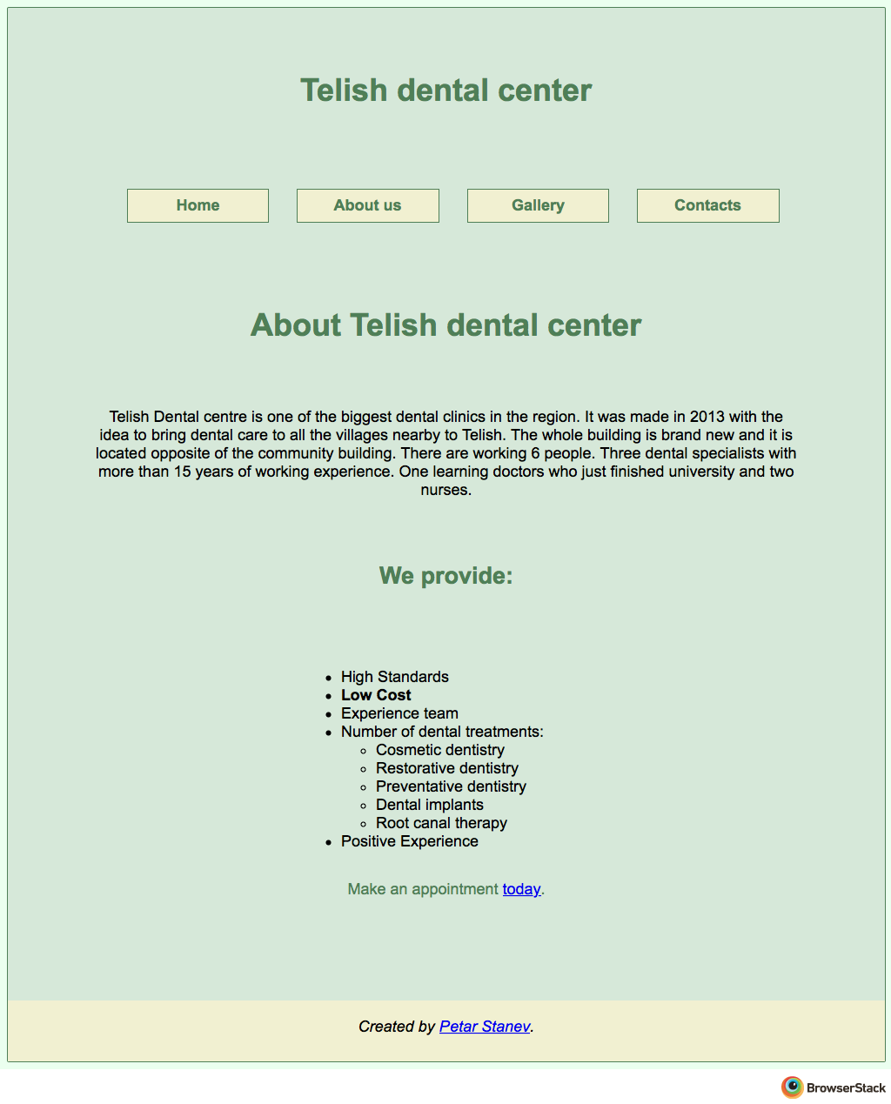

* Windows 7 Internet Explorer 9.0

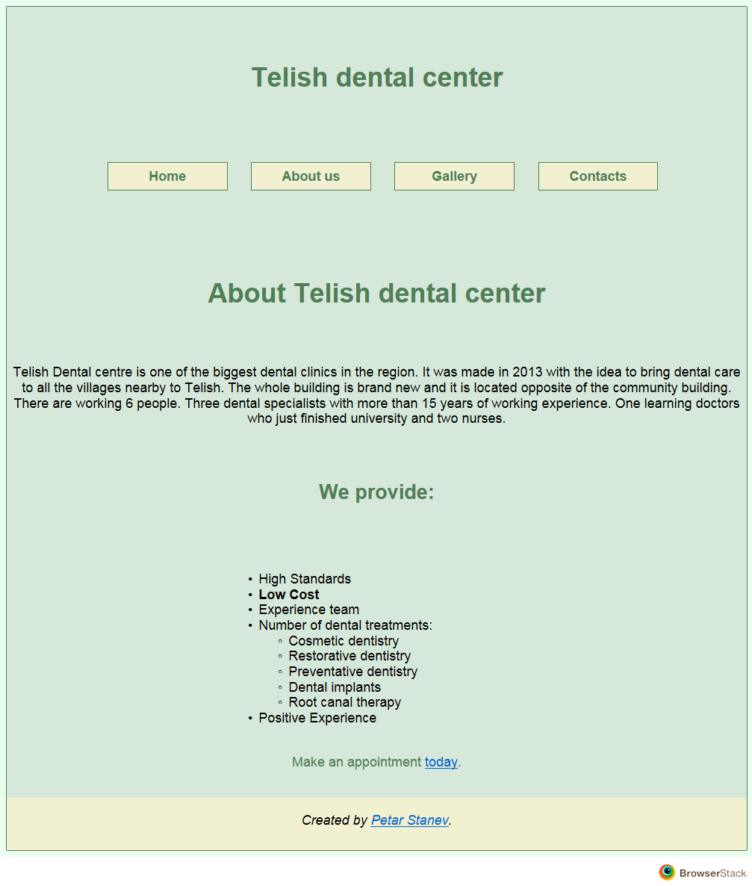

* Windows 8.1 Internet Explorer 11.0

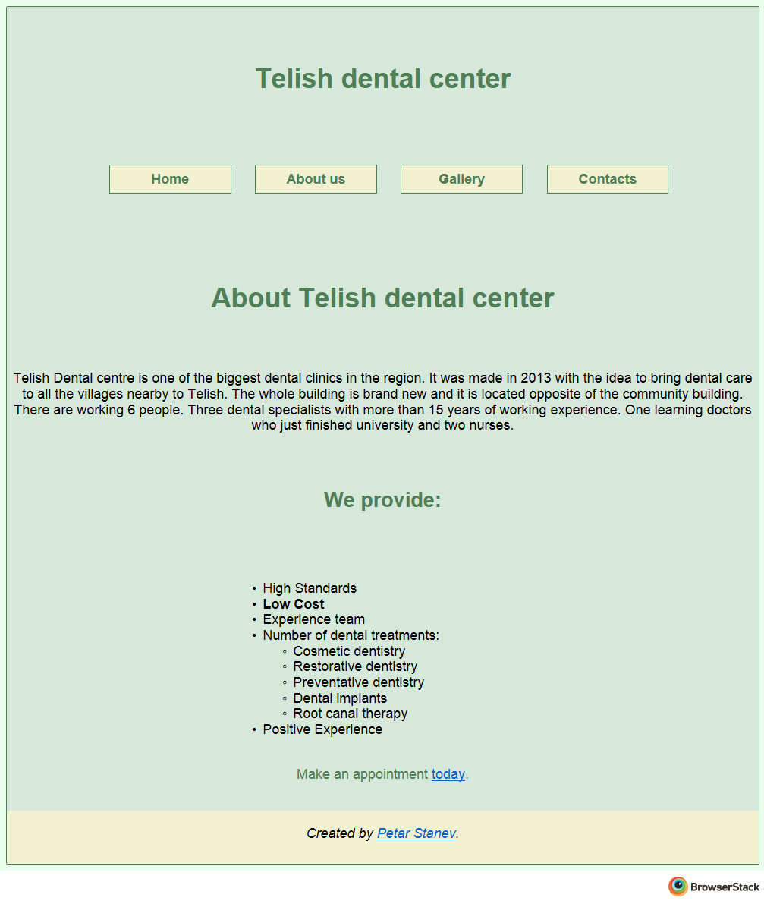

## 5.2 Mobile and tablet

* Android Samsung Galaxy S5

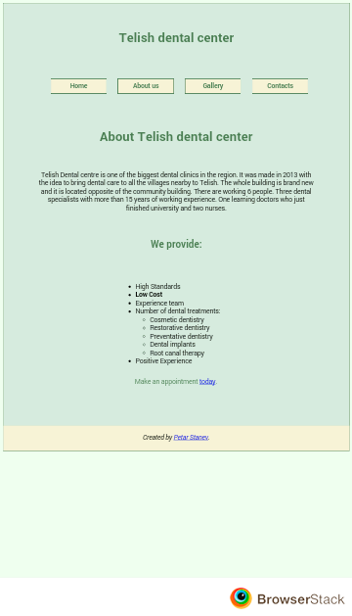

* Ios iPad



* Ios iPhone 5S



* Ios iPhone 6 Plus

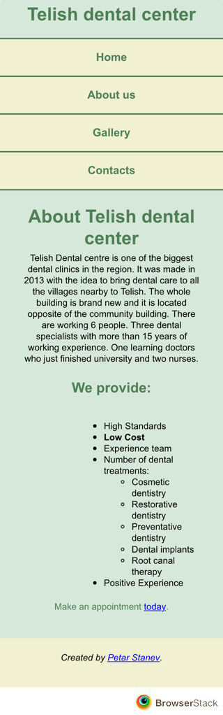

## 5.3 Other

* Lynx

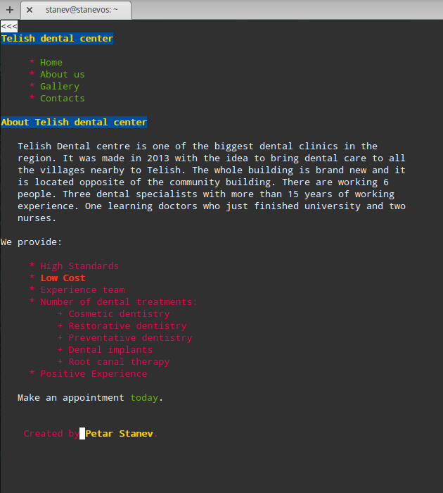

# 6. Validation

## 6.1 HTML5 validation

Index page

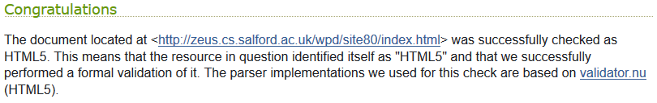

About us

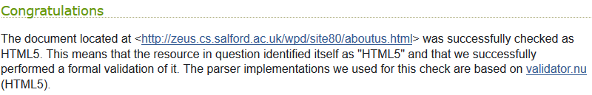

Gallery

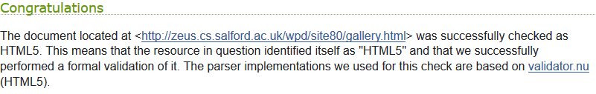

Contacts

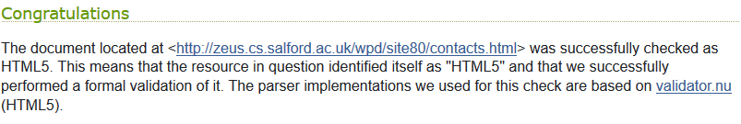

## 6.2 CSS validation

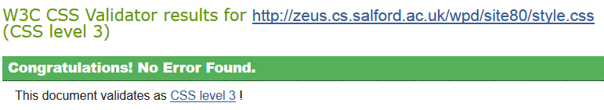

# 7. Copyright permission

